Final Assessment-Alternative Assessment
Semester | 202520 | Division | CIS
Assessment title in Syllabus | Final_Project_Portfolio | Program | Bachelor of Information Technology/ Bachelor of Information Systems
Course Code | CDS 2413
Course Title | INTRODUCTION TO DATA SCIENCE
Course Instructor |  | CRN
Assessment | Project Deliverable 2 – Machine Learning Model Report | Submission Date | Week 13
Student Declaration:
Academic Integrity Statement
In accordance with the HCT Academic Integrity Policy
• Students are required to refrain from all forms of academic integrity breaches as defined and explained by HCT.
• A student found guilty of having committed acts of academic integrity breach(es) will be subject to the relevant sanctions as outlined by HCT.
إفادة النزاهة الأكاديمية
وفقًا لسياسة كليات التقنية العليا للنزاهة الأكاديمية
• على الطلبة الإلتزام بلوائح وقواعد النزاهة الأكاديمية، كما هو مبيّن وموضح في السياسات والإجراءات الخاصة بكليات التقنية العليا.
• في حالة ارتكاب الطالب أي شكل من أشكال الإخلال بالنزاهة الأكاديمية، سيتعرض الى العقوبات الموضحة في السياسات ذات الصلة.
This assignment is entirely my/our own work except where I have duly acknowledged other sources in the text and listed those sources at the end of the assignment. I have not previously submitted this work to the HCT, or any other entity. I understand that I may be orally examined on my submission.

Student HCT ID(s): | H00 | H00 | H00 | H00
Student Name(s):
Student Signature
Chatbot (e.g. ChatGPT) statement
This submission allows you to use AI generated tools, but the prompt used must be stated and the response must be in red font. Include References to ChatGPT.

Instructions

Remove instructions and hints from the template before submitting the final report to BBLearn.

CLO3: Machine Learning Model (25 Points)

Preprocessing(5 Points)

Data Collection (1 Point)
To read data from CSV files, the pandas library is used via pd.read_csv(). The dataset used is StudentPerformanceFactors.csv, which contains 6,607 rows and 20 columns.
Exam_Score is the dependent variable (target), as it is the outcome we want to predict, it represents a student's final exam performance.
The remaining 19 columns are independent variables (features). These are the factors that influence the exam score.

Data Cleaning (1 Point)
The dataset was inspected for missing values using df.isnull().sum(). Three columns were found to have missing values:
- Teacher_Quality: 78 missing values
- Parental_Education_Level: 90 missing values
- Distance_from_Home: 67 missing values
Since these are categorical columns, missing values were filled using the mode of each column, as mean/median is not applicable to categorical data. Duplicate rows were also checked and removed using df.drop_duplicates().

Treating the Categorical Variables (1 Point)
The dataset contains the following categorical variables among the independent variables:
- Binary (Yes/No): Extracurricular_Activities, Internet_Access, Learning_Disabilities, Gender, School_Type → encoded using Label Encoding (0 and 1), since there are only two categories.
- Ordinal (Low/Medium/High or ordered): Parental_Involvement, Access_to_Resources, Motivation_Level, Family_Income, Teacher_Quality, Parental_Education_Level, Distance_from_Home → encoded using Ordinal Encoding, since these have a natural order.
- Nominal (no natural order): Peer_Influence (Positive/Negative/Neutral) → encoded using One-Hot Encoding, since there is no meaningful order between categories.
The dependent variable Exam_Score is numerical and requires no encoding.

Splitting the Dataset (1 Point)
Splitting the dataset is important to evaluate how well the model generalizes to unseen data. If the model is trained and tested on the same data, it may overfit. A separate test set allows us to get an unbiased measure of model performance.
The dataset was split using an 80% training / 20% testing ratio using train_test_split() from sklearn.model_selection. This is the most common split in practice, 80% provides enough data for the model to learn patterns, while 20% is sufficient to evaluate performance reliably. A random_state was set to ensure randomness.

Featuring the Dataset (1 Point)
Yes, feature scaling was applied using StandardScaler from sklearn.preprocessing. This technique standardizes features by removing the mean and scaling to unit variance (z-score normalization).
Scaling was necessary because the numerical columns in the dataset have different ranges. Without scaling, models such as Ridge, Lasso, Elastic Net, and KNN would give disproportional weight to features with larger numeric ranges, leading to biased results. Note: StandardScaler was applied only to the training set and then used to transform the test set, to avoid data leakage.

Regression Model (7 Points)

Building the Regression Model (6 points)
# STEP 1 - IMPORT LIBRARIES
import pandas as pd
import numpy as np
import matplotlib.pyplot as plt
from sklearn.preprocessing import LabelEncoder, StandardScaler, PolynomialFeatures
from sklearn.model_selection import train_test_split
from sklearn.linear_model import LinearRegression, Ridge, Lasso, ElasticNet
from sklearn.metrics import mean_squared_error, r2_score

# STEP 2 - LOAD DATASET
df = pd.read_csv('StudentPerformanceFactors.csv')
print("Dataset Shape:", df.shape)
print("\nFirst 5 rows:")
print(df.head())

# STEP 3 - DATA CLEANING (Fill missing values with mode)
for col in ['Teacher_Quality', 'Parental_Education_Level', 'Distance_from_Home']:
df[col] = df[col].fillna(df[col].mode()[0])

df = df.drop_duplicates().reset_index(drop=True)
print("\nMissing values after cleaning:")
print(df.isnull().sum())

# STEP 4 - ENCODING CATEGORICAL VARIABLES

binary_cols = ['Extracurricular_Activities', 'Internet_Access',
'Learning_Disabilities', 'Gender', 'School_Type']
le = LabelEncoder()
for col in binary_cols:
df[col] = le.fit_transform(df[col])

ordinal_map = {
'Parental_Involvement': {'Low': 0, 'Medium': 1, 'High': 2},
'Access_to_Resources': {'Low': 0, 'Medium': 1, 'High': 2},
'Motivation_Level': {'Low': 0, 'Medium': 1, 'High': 2},
'Family_Income': {'Low': 0, 'Medium': 1, 'High': 2},
'Teacher_Quality': {'Low': 0, 'Medium': 1, 'High': 2},
'Parental_Education_Level': {'High School': 0, 'College': 1, 'Postgraduate': 2},
'Distance_from_Home': {'Near': 0, 'Moderate': 1, 'Far': 2},
}
for col, mapping in ordinal_map.items():
df[col] = df[col].map(mapping)

df = pd.get_dummies(df, columns=['Peer_Influence'], drop_first=True)

print("\nDataset after encoding:")
print(df.head())

# STEP 5 - SPLIT INTO INDEPENDENT (X) AND DEPENDENT (y)
X = df.drop('Exam_Score', axis=1)
y = df['Exam_Score']

print("\nIndependent Variables (X) shape:", X.shape)
print("Dependent Variable (y) shape:", y.shape)

# STEP 6 - TRAIN-TEST SPLIT (80/20)
X_train, X_test, y_train, y_test = train_test_split(
X, y, test_size=0.2, random_state=42
)
print("\nTraining set size:", X_train.shape)
print("Testing set size:", X_test.shape)

# STEP 7 - FEATURE SCALING (StandardScaler)
scaler = StandardScaler()
X_train_sc = scaler.fit_transform(X_train)
X_test_sc = scaler.transform(X_test)

# STEP 8 - BUILD AND EVALUATE REGRESSION MODELS
results = []
trained_models = {}

# --- Linear Regression ---
lr = LinearRegression()
lr.fit(X_train_sc, y_train)
y_pred_lr = lr.predict(X_test_sc)
results.append({'Model': 'Linear Regression',
'MSE': round(mean_squared_error(y_test, y_pred_lr), 4),
'R²': round(r2_score(y_test, y_pred_lr), 4)})
trained_models['Linear Regression'] = lr

# --- Polynomial Regression (degree 2) ---
poly = PolynomialFeatures(degree=2)
X_train_poly = poly.fit_transform(X_train_sc)
X_test_poly = poly.transform(X_test_sc)
pr = LinearRegression()
pr.fit(X_train_poly, y_train)
y_pred_pr = pr.predict(X_test_poly)
results.append({'Model': 'Polynomial Regression (deg 2)',
'MSE': round(mean_squared_error(y_test, y_pred_pr), 4),
'R²': round(r2_score(y_test, y_pred_pr), 4)})

# --- Ridge Regression ---
ridge = Ridge(alpha=1.0)
ridge.fit(X_train_sc, y_train)
y_pred_ridge = ridge.predict(X_test_sc)
results.append({'Model': 'Ridge Regression',
'MSE': round(mean_squared_error(y_test, y_pred_ridge), 4),
'R²': round(r2_score(y_test, y_pred_ridge), 4)})
trained_models['Ridge Regression'] = ridge

# --- Lasso Regression ---
lasso = Lasso(alpha=0.1)
lasso.fit(X_train_sc, y_train)
y_pred_lasso = lasso.predict(X_test_sc)
results.append({'Model': 'Lasso Regression',
'MSE': round(mean_squared_error(y_test, y_pred_lasso), 4),
'R²': round(r2_score(y_test, y_pred_lasso), 4)})
trained_models['Lasso Regression'] = lasso

# --- Elastic Net ---
en = ElasticNet(alpha=0.1, l1_ratio=0.5)
en.fit(X_train_sc, y_train)
y_pred_en = en.predict(X_test_sc)
results.append({'Model': 'Elastic Net',
'MSE': round(mean_squared_error(y_test, y_pred_en), 4),
'R²': round(r2_score(y_test, y_pred_en), 4)})
trained_models['Elastic Net'] = en

# STEP 9 - MODEL COMPARISON TABLE
results_df = pd.DataFrame(results).sort_values('R²', ascending=False).reset_index(drop=True)
print("\n========== MODEL COMPARISON ==========")
print(results_df.to_string(index=False))

best_name = results_df.iloc[0]['Model']
print(f"\nBest Fit Model: {best_name}")

# STEP 10 - PRINT REGRESSION EQUATIONS (All Models)

cols = list(X.columns)

print("\n" + "="*60)
print("Linear Regression Equation:")
eq = f"Exam_Score = {round(lr.intercept_, 4)}"
for c, col in zip(lr.coef_, cols):
eq += f" + ({round(c, 4)})*{col}"
print(eq)

print("\n" + "="*60)
print("Ridge Regression Equation:")
eq = f"Exam_Score = {round(ridge.intercept_, 4)}"
for c, col in zip(ridge.coef_, cols):
eq += f" + ({round(c, 4)})*{col}"
print(eq)

print("\n" + "="*60)
print("Lasso Regression Equation:")
eq = f"Exam_Score = {round(lasso.intercept_, 4)}"
for c, col in zip(lasso.coef_, cols):
eq += f" + ({round(c, 4)})*{col}"
print(eq)

print("\n" + "="*60)
print("Elastic Net Equation:")
eq = f"Exam_Score = {round(en.intercept_, 4)}"
for c, col in zip(en.coef_, cols):
eq += f" + ({round(c, 4)})*{col}"
print(eq)

print("\n" + "="*60)
print("Polynomial Regression (degree 2) Equation:")
feature_names = poly.get_feature_names_out(cols)
eq = f"Exam_Score = {round(pr.intercept_, 4)}"
for c, fname in zip(pr.coef_[1:11], feature_names[1:11]):
eq += f" + ({round(c, 4)})*{fname}"
eq += " + ... (231 total terms)"
print(eq)

# STEP 11 - SCATTER PLOT: Observed vs Predicted (Best Model)
best_preds = trained_models[best_name].predict(X_test_sc)

plt.figure(figsize=(8, 6))
plt.scatter(y_test, best_preds, alpha=0.4, color='steelblue', label='Predicted vs Actual')
plt.plot([y_test.min(), y_test.max()],
[y_test.min(), y_test.max()],
color='red', linewidth=2, label='Perfect Prediction Line')
plt.xlabel('Observed Exam Score')
plt.ylabel('Predicted Exam Score')
plt.title(f'Observed vs Predicted - {best_name}')
plt.legend()
plt.tight_layout()
plt.savefig('regression_scatter.png', dpi=150)
plt.show()
print("\nScatter plot saved as regression_scatter.png")

Dataset shape
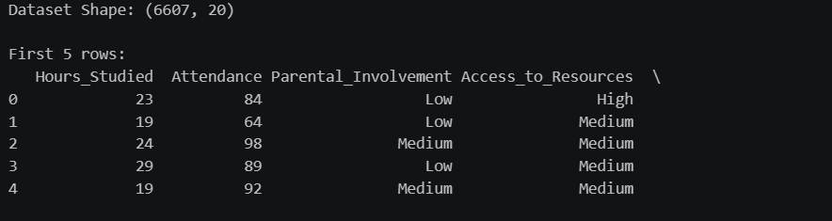

Missing values after cleaning
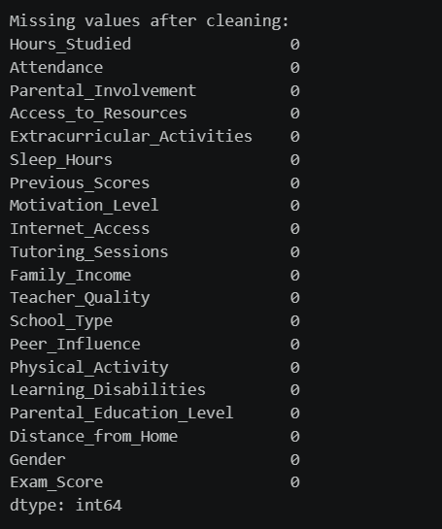

The model comparison table
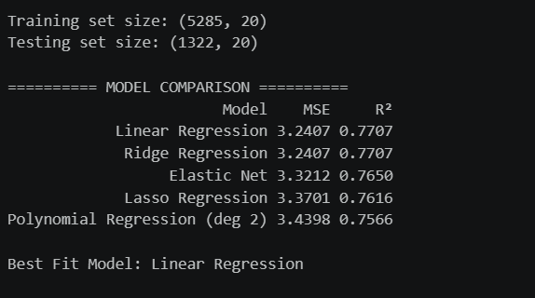

The regression equation
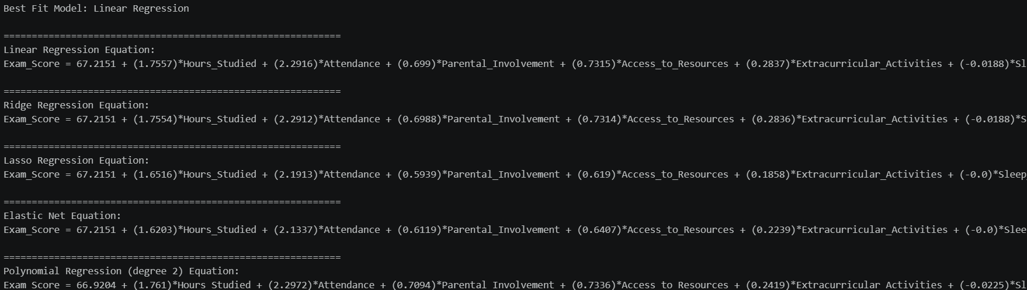

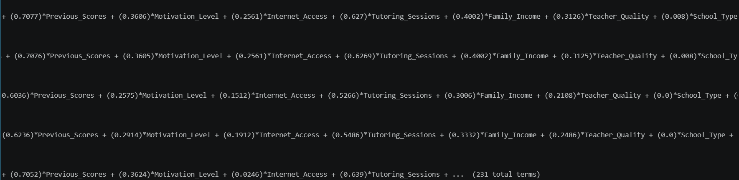
Contd. Couldn’t paste it all since it was too long.

ScatterPlot
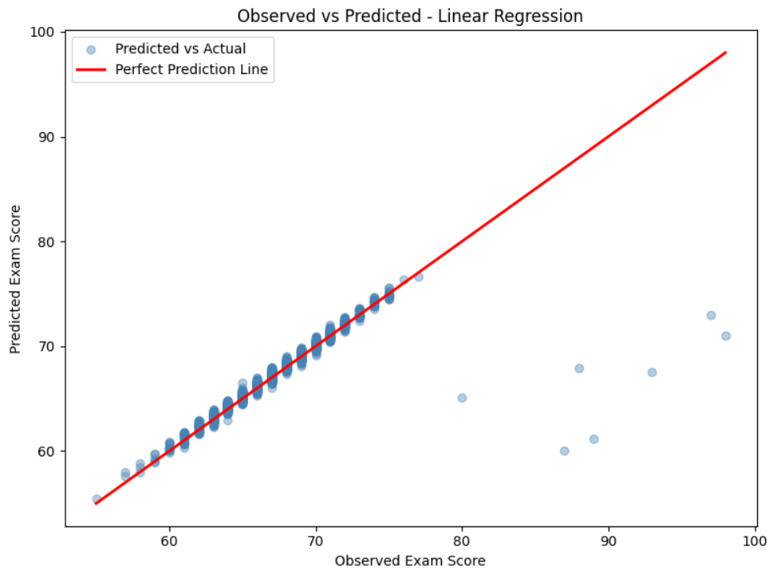

Deriving the Regression Equation the Dataset (1 point)
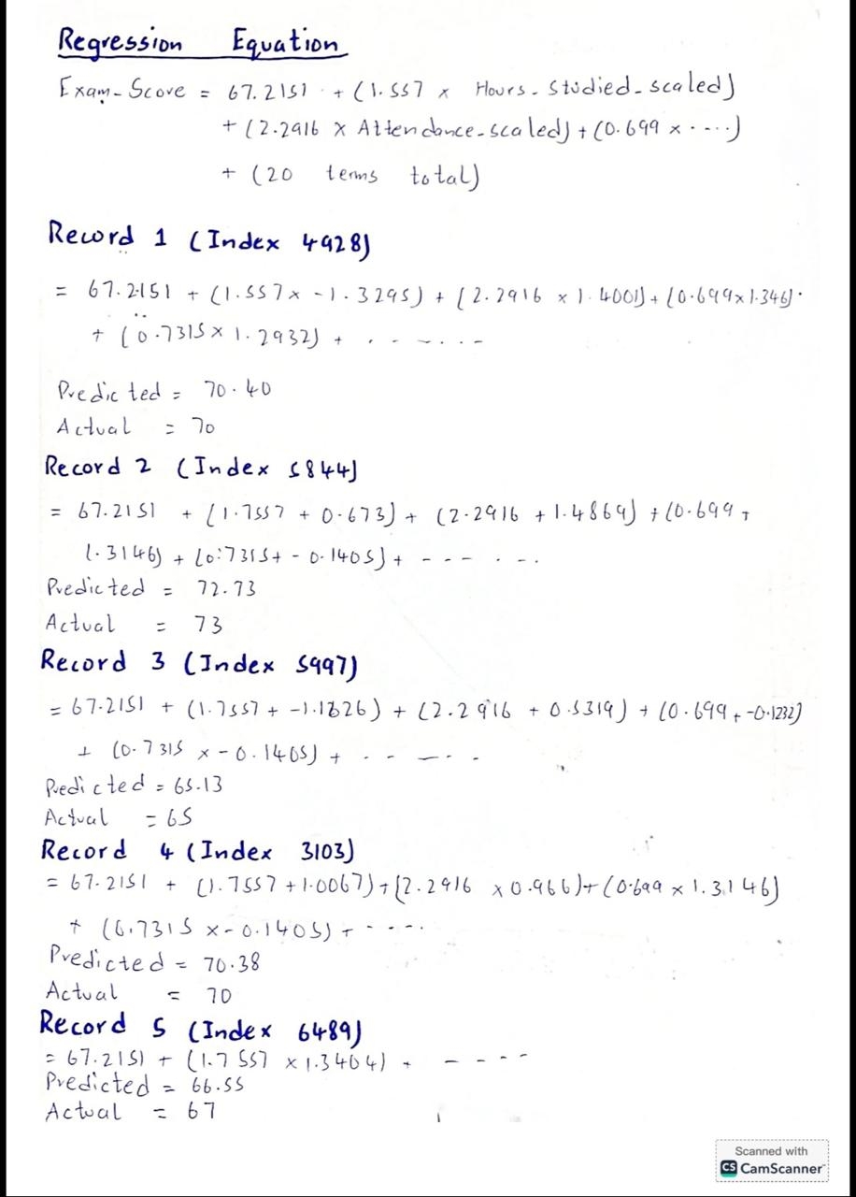

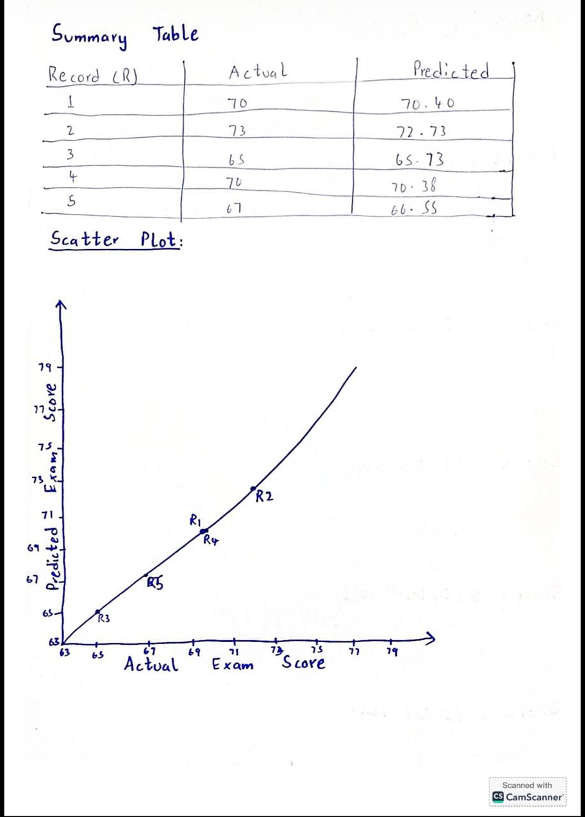

Classification Model (8 Points)

Classifying the dataset based on the target variable (1 Point)
The target variable Exam_Score was converted into three performance categories: Low (score < 65), Medium (65 ≤ score ≤ 70), and High (score > 70). This threshold was chosen based on the dataset's mean score of 67, making Medium the average-performing group.

Bulding classification models (6 Points)
# STEP 1 - IMPORT LIBRARIES

import pandas as pd
import numpy as np
from sklearn.preprocessing import LabelEncoder, StandardScaler
from sklearn.model_selection import train_test_split
from sklearn.linear_model import LogisticRegression
from sklearn.neighbors import KNeighborsClassifier
from sklearn.svm import SVC
from sklearn.tree import DecisionTreeClassifier
from sklearn.ensemble import RandomForestClassifier
from sklearn.metrics import (confusion_matrix, accuracy_score,
precision_score, recall_score, f1_score)

# STEP 2 - LOAD AND PREPROCESS DATASET

df = pd.read_csv('StudentPerformanceFactors.csv')

for col in ['Teacher_Quality', 'Parental_Education_Level', 'Distance_from_Home']:
df[col] = df[col].fillna(df[col].mode()[0])
df = df.drop_duplicates().reset_index(drop=True)

binary_cols = ['Extracurricular_Activities', 'Internet_Access',
'Learning_Disabilities', 'Gender', 'School_Type']
le = LabelEncoder()
for col in binary_cols:
df[col] = le.fit_transform(df[col])

ordinal_map = {
'Parental_Involvement': {'Low': 0, 'Medium': 1, 'High': 2},
'Access_to_Resources': {'Low': 0, 'Medium': 1, 'High': 2},
'Motivation_Level': {'Low': 0, 'Medium': 1, 'High': 2},
'Family_Income': {'Low': 0, 'Medium': 1, 'High': 2},
'Teacher_Quality': {'Low': 0, 'Medium': 1, 'High': 2},
'Parental_Education_Level': {'High School': 0, 'College': 1, 'Postgraduate': 2},
'Distance_from_Home': {'Near': 0, 'Moderate': 1, 'Far': 2},
}
for col, mapping in ordinal_map.items():
df[col] = df[col].map(mapping)

df = pd.get_dummies(df, columns=['Peer_Influence'], drop_first=True)

# STEP 3 - DEFINE TARGET VARIABLE (3 Performance Categories)

def classify_score(score):
if score < 65:
return 0 # Low
elif score <= 70:
return 1 # Medium
else:
return 2 # High

df['Performance'] = df['Exam_Score'].apply(classify_score)
labels_map = {0: 'Low', 1: 'Medium', 2: 'High'}

print("===== TARGET VARIABLE CLASS DISTRIBUTION =====")
for k, v in labels_map.items():
print(f" {v}: {(df['Performance'] == k).sum()} students")

# STEP 4 - TRAIN-TEST SPLIT AND FEATURE SCALING

X = df.drop(['Exam_Score', 'Performance'], axis=1)
y = df['Performance']

X_train, X_test, y_train, y_test = train_test_split(
X, y, test_size=0.2, random_state=42
)

scaler = StandardScaler()
X_train_sc = scaler.fit_transform(X_train)
X_test_sc = scaler.transform(X_test)

# STEP 5 - BUILD AND EVALUATE ALL MODELS

models = {
'Logistic Regression': LogisticRegression(max_iter=1000, random_state=42),
'K-Nearest Neighbors': KNeighborsClassifier(n_neighbors=5),
'Support Vector Machine': SVC(kernel='rbf', random_state=42),
'Decision Tree': DecisionTreeClassifier(random_state=42),
'Random Forest': RandomForestClassifier(n_estimators=100, random_state=42),
}

rows = []
best_acc = 0
best_name = ''
best_pred = None

for name, model in models.items():
model.fit(X_train_sc, y_train)
y_pred = model.predict(X_test_sc)
cm = confusion_matrix(y_test, y_pred)
errors = int(len(y_test) - accuracy_score(y_test, y_pred, normalize=False))
acc = round(accuracy_score(y_test, y_pred), 4)
prec = round(precision_score(y_test, y_pred, average='weighted'), 4)
rec = round(recall_score(y_test, y_pred, average='weighted'), 4)
f1 = round(f1_score(y_test, y_pred, average='weighted'), 4)
cm_str = f"{cm[0].tolist()}\n {cm[1].tolist()}\n {cm[2].tolist()}"
rows.append([name, cm_str, errors, acc, prec, rec, f1])
if acc > best_acc:
best_acc = acc
best_name = name
best_pred = y_pred

# STEP 6 - TABLE 1: Confusion Matrix + Errors + Accuracy

print("\n" + "=" * 105)
print("Cross-Validation Classification Model Results")
print("=" * 105)
print(f"{'No':<4} {'Model':<25} {'Confusion Matrix':<38} {'Errors (FP+FN)':<16} {'Accuracy'}")
print("-" * 105)
for i, (name, cm_str, err, acc, prec, rec, f1) in enumerate(rows, 1):
first_line = cm_str.split('\n')[0]
print(f"{i:<4} {name:<25} {first_line:<38} {err:<16} {acc}")
for extra_line in cm_str.split('\n')[1:]:
print(f"{'':4} {'':25} {extra_line}")
print("=" * 105)

# STEP 7 - TABLE 2: Precision, Recall, F1-Score

print("\n" + "=" * 75)
print("Model Evaluation Metrics")
print("=" * 75)
print(f"{'No':<4} {'Model':<25} {'Accuracy':<12} {'Precision':<12} {'Recall':<12} {'F1-Score'}")
print("-" * 75)
for i, (name, cm_str, err, acc, prec, rec, f1) in enumerate(rows, 1):
print(f"{i:<4} {name:<25} {acc:<12} {prec:<12} {rec:<12} {f1}")
print("=" * 75)

print(f"\nBest Classifier: {best_name} (Accuracy: {best_acc})")

# STEP 8 - CLASS COUNT IN BEST MODEL PREDICTIONS

print(f"\n===== NUMBER OF ELEMENTS PER CATEGORY =====")
print(f"(Based on Best Classifier: {best_name})\n")
unique, counts = np.unique(best_pred, return_counts=True)
for u, c in zip(unique, counts):
print(f" {labels_map[u]}: {c} students")

Evaluation Metrics
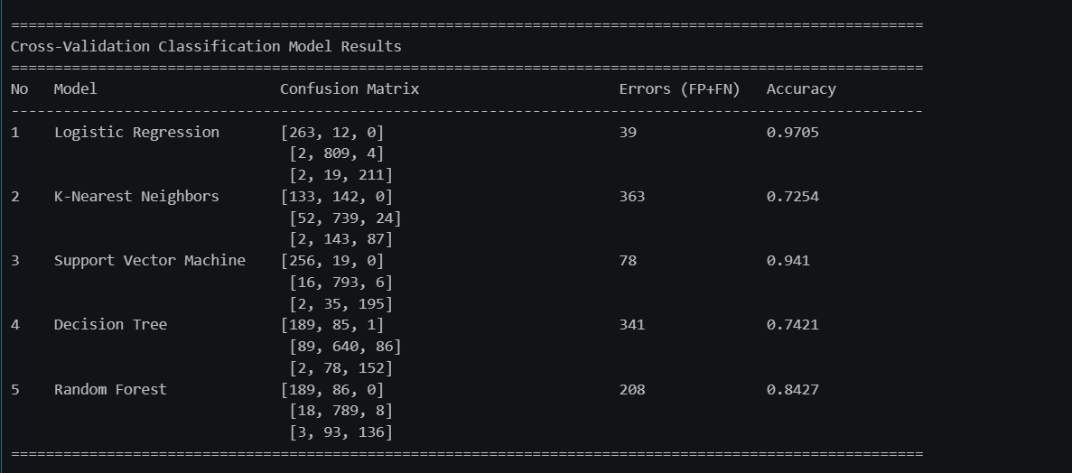

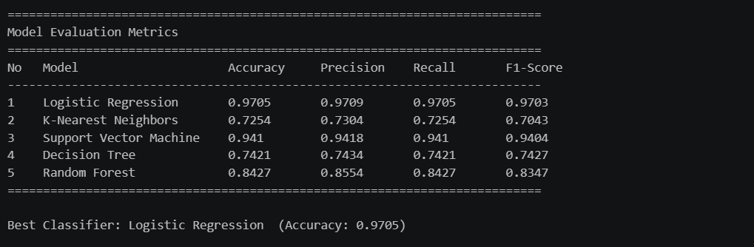

No of elements on the target variable (1 Point)
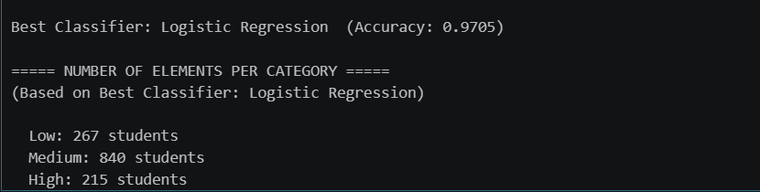

Cluster Analysis (5 Points)
Building the Cluster Analysis(3 Points)
# STEP 1 - IMPORT LIBRARIES

import pandas as pd
import numpy as np
import matplotlib.pyplot as plt
from sklearn.preprocessing import LabelEncoder, StandardScaler
from sklearn.cluster import KMeans
from sklearn.metrics import silhouette_score
import warnings
warnings.filterwarnings('ignore')

# STEP 2 - LOAD AND PREPROCESS DATASET

df = pd.read_csv('StudentPerformanceFactors.csv')

for col in ['Teacher_Quality', 'Parental_Education_Level', 'Distance_from_Home']:
df[col] = df[col].fillna(df[col].mode()[0])
df = df.drop_duplicates().reset_index(drop=True)

binary_cols = ['Extracurricular_Activities', 'Internet_Access',
'Learning_Disabilities', 'Gender', 'School_Type']
le = LabelEncoder()
for col in binary_cols:
df[col] = le.fit_transform(df[col])

ordinal_map = {
'Parental_Involvement': {'Low': 0, 'Medium': 1, 'High': 2},
'Access_to_Resources': {'Low': 0, 'Medium': 1, 'High': 2},
'Motivation_Level': {'Low': 0, 'Medium': 1, 'High': 2},
'Family_Income': {'Low': 0, 'Medium': 1, 'High': 2},
'Teacher_Quality': {'Low': 0, 'Medium': 1, 'High': 2},
'Parental_Education_Level': {'High School': 0, 'College': 1, 'Postgraduate': 2},
'Distance_from_Home': {'Near': 0, 'Moderate': 1, 'Far': 2},
}
for col, mapping in ordinal_map.items():
df[col] = df[col].map(mapping)

df = pd.get_dummies(df, columns=['Peer_Influence'], drop_first=True)

# STEP 3 - SELECT FEATURES FOR CLUSTERING

features = ['Hours_Studied', 'Attendance', 'Previous_Scores',
'Exam_Score', 'Motivation_Level', 'Tutoring_Sessions', 'Sleep_Hours']

X_cluster = df[features]
scaler = StandardScaler()
X_scaled = scaler.fit_transform(X_cluster)

# STEP 4 - ELBOW METHOD (Find Optimal K)
inertias = []
K_range = range(1, 11)

for k in K_range:
km = KMeans(n_clusters=k, random_state=42, n_init=10)
km.fit(X_scaled)
inertias.append(km.inertia_)

plt.figure(figsize=(8, 5))
plt.plot(K_range, inertias, 'bo-', markersize=8, linewidth=2)
plt.axvline(x=3, color='red', linestyle='--', label='Optimal K = 3')
plt.xlabel('Number of Clusters (K)', fontsize=12)
plt.ylabel('Inertia (Within-Cluster Sum of Squares)', fontsize=12)
plt.title('Elbow Method — Optimal Number of Clusters', fontsize=13, fontweight='bold')
plt.xticks(K_range)
plt.legend()
plt.grid(True, alpha=0.3)
plt.tight_layout()
plt.savefig('elbow_plot.png', dpi=150)
plt.show()
print("Elbow plot saved.")

# STEP 5 - APPLY K-MEANS WITH K=3

km_final = KMeans(n_clusters=3, random_state=42, n_init=10)
df['Cluster'] = km_final.fit_predict(X_scaled)

# Label clusters by Exam_Score mean (Low / Average / High)
cluster_means = df.groupby('Cluster')['Exam_Score'].mean().sort_values()
rename_map = {
cluster_means.index[0]: 'Low Performers',
cluster_means.index[1]: 'Average Performers',
cluster_means.index[2]: 'High Performers'
}
df['Cluster_Label'] = df['Cluster'].map(rename_map)

print("\n===== CLUSTER SIZES =====")
print(df['Cluster_Label'].value_counts().to_string())

print("\n===== CLUSTER FEATURE MEANS =====")
print(df.groupby('Cluster_Label')[features].mean().round(2).to_string())

# STEP 6 - VISUALIZATION 1: Attendance vs Exam Score

colors = {
'Low Performers': '#e74c3c',
'Average Performers': '#3498db',
'High Performers': '#2ecc71'
}

plt.figure(figsize=(9, 6))
for label, color in colors.items():
mask = df['Cluster_Label'] == label
plt.scatter(df[mask]['Attendance'], df[mask]['Exam_Score'],
c=color, alpha=0.4, s=20, label=label)

# Plot cluster centroids
centers_orig = scaler.inverse_transform(km_final.cluster_centers_)
centers_df = pd.DataFrame(centers_orig, columns=features)
centers_df['Cluster_Label'] = centers_df.index.map(rename_map)
for _, row in centers_df.iterrows():
plt.scatter(row['Attendance'], row['Exam_Score'],
c='black', marker='*', s=300, zorder=5)

plt.xlabel('Attendance (%)', fontsize=12)
plt.ylabel('Exam Score', fontsize=12)
plt.title('K-Means Clustering (K=3)\nAttendance vs Exam Score', fontsize=13, fontweight='bold')
plt.legend(fontsize=10)
plt.grid(True, alpha=0.3)
plt.tight_layout()
plt.savefig('cluster_scatter.png', dpi=150)
plt.show()
print("Cluster scatter plot (Attendance vs Exam Score) saved.")

# STEP 7 - VISUALIZATION 2: Hours Studied vs Exam Score

plt.figure(figsize=(9, 6))
for label, color in colors.items():
mask = df['Cluster_Label'] == label
plt.scatter(df[mask]['Hours_Studied'], df[mask]['Exam_Score'],
c=color, alpha=0.4, s=20, label=label)
for _, row in centers_df.iterrows():
plt.scatter(row['Hours_Studied'], row['Exam_Score'],
c='black', marker='*', s=300, zorder=5)

plt.xlabel('Hours Studied', fontsize=12)
plt.ylabel('Exam Score', fontsize=12)
plt.title('K-Means Clustering (K=3)\nHours Studied vs Exam Score', fontsize=13, fontweight='bold')
plt.legend(fontsize=10)
plt.grid(True, alpha=0.3)
plt.tight_layout()
plt.savefig('cluster_hours.png', dpi=150)
plt.show()
print("Cluster scatter plot (Hours Studied vs Exam Score) saved.")

Cluster Sizes And Cluster Feature Means
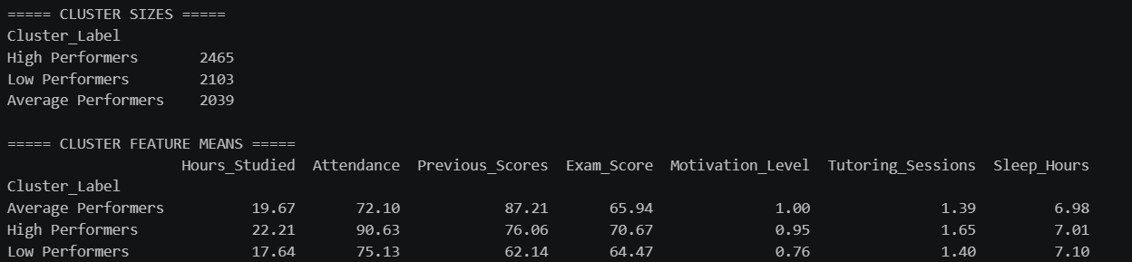

Visualizations
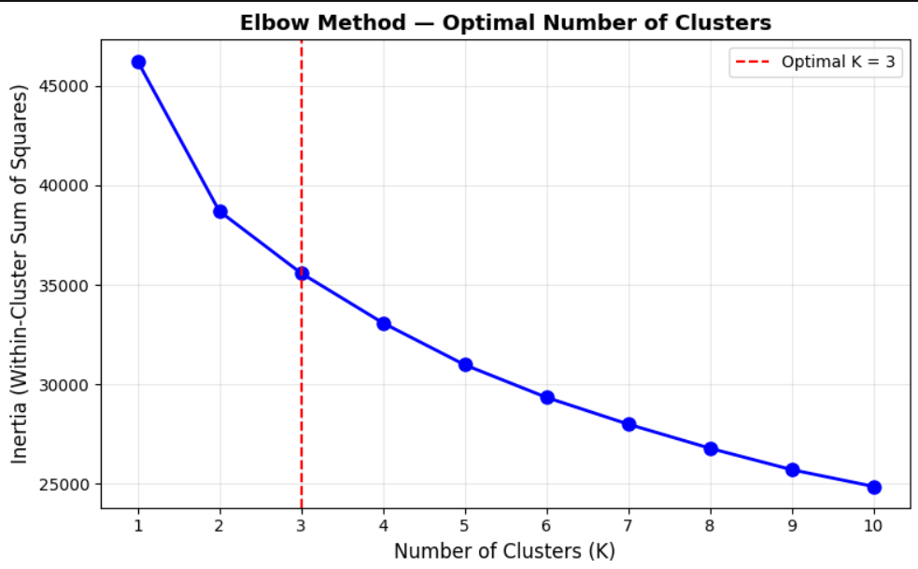

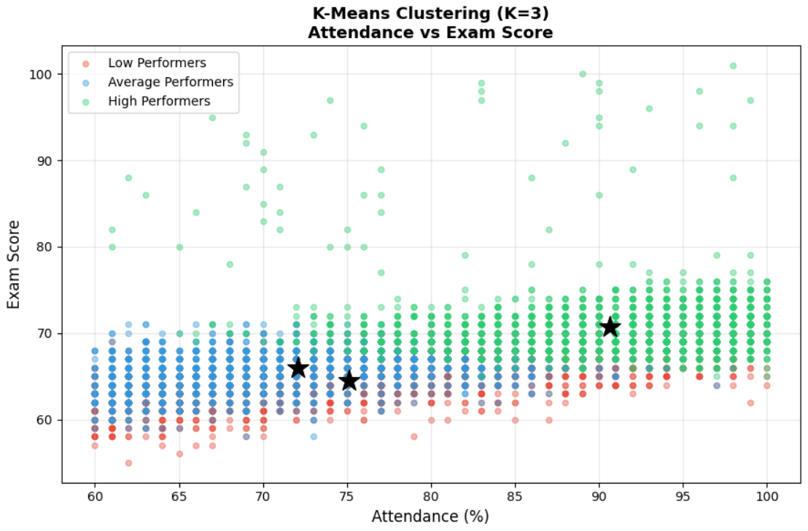

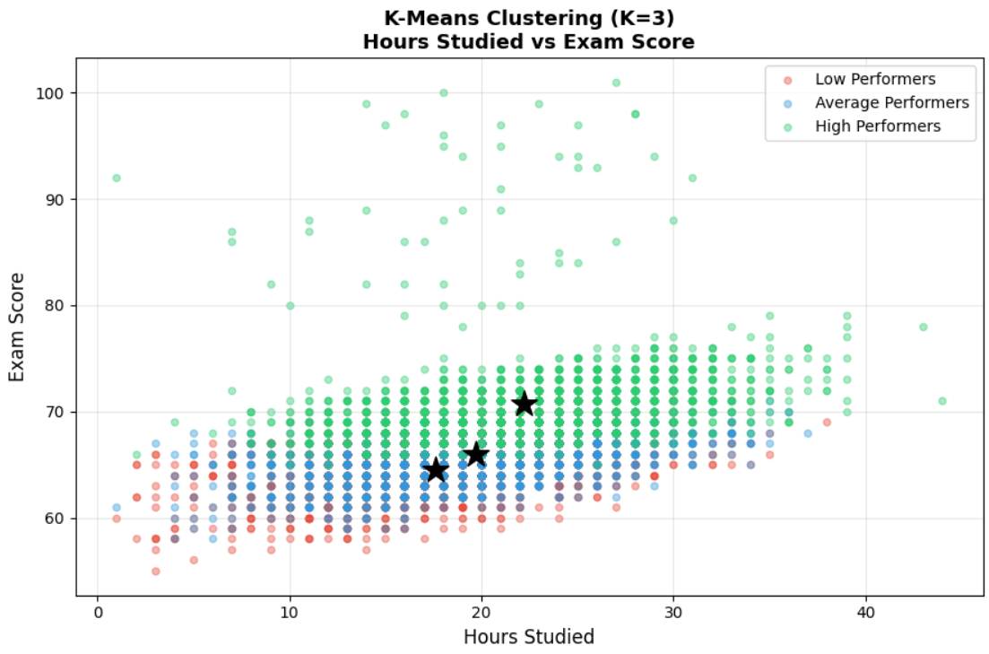

Strategy Formulation(2 Points)
Cluster 1 — High Performers (2,465 students)
These students have the highest attendance (avg 90.6%), study the most hours (avg 22.2), and score highest on exams (avg 70.7). They also attend the most tutoring sessions.
Strategy: Maintain their engagement through advanced coursework, academic competitions, and scholarship opportunities to keep them challenged and motivated.
Cluster 2 — Average Performers (2,039 students)
These students have moderate study hours (avg 19.7) but low attendance (avg 72.1%) despite having high previous scores (avg 87.2). Their exam scores are around 65.9.
Strategy: Focus on improving attendance through incentive programs and early warning systems. Since their previous scores are high, they have the potential to move into the High Performers cluster with better consistency.
Cluster 3 — Low Performers (2,103 students)
These students have the fewest study hours (avg 17.6), lowest previous scores (avg 62.1), and lowest exam scores (avg 64.5). Motivation level is also the lowest across all clusters.
Strategy: Provide targeted intervention programs, remedial classes, one-on-one tutoring, and motivational counseling. Early identification of these students allows instructors to give them extra attention before exams.

End of Documentation.

